**Guide to using Better Table Wizard**

1. Get your table ready on an Excel spreadsheet. Make sure your table has a title and all rows and columns have headings.
2. Select your table in Excel and copy it (In this example, the county names serve as the row headers:

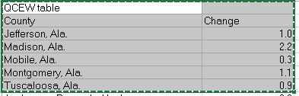

1. Go to the Better Table Wizard page at <http://opubrev08.bls.gov/xxx_test/jay/chart_maker/better_table_wizard.htm>
2. Paste your text into the first box:  
   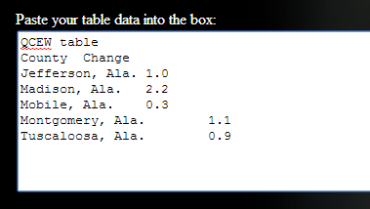
3. Give your table a unique ID (to be used for 508-compliance), and chose any desired options:  
   
4. Click the “Make Table” Button:



1. Check that your table looks right:  
   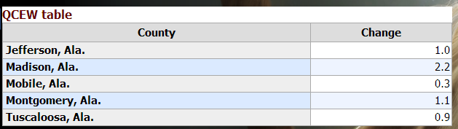  
     
   If it doesn’t look how you expect it to, please read the troubleshooting section toward the bottom of the page. If you’re still having trouble, contact Jay McDaniel at [mcdaniel.jay@bls.gov](mailto:mcdaniel.jay@bls.gov)
2. Select and copy all of the code in the second box:  
   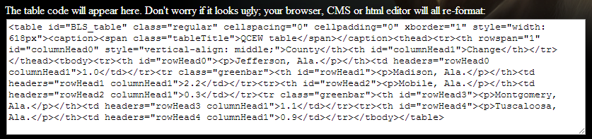
3. Paste the code onto the html page or the Rythmyx table entry box where you want the table to go. In Rythmyx, the box looks like the following image. Make sure you click on the “code” tab first and delete any code in the box first.  
     
   